NORTH-WEST UNIVERSITY (NWU)
FACULTY OF NATURAL AND AGRICULTURAL SCIENCES
SCHOOL OF COMPUTER SCIENCE AND INFORMATION SYSTEMS
ITRI626: ARTIFICIAL INTELLIGENCE / DEEP LEARNING FOR IMAGE CLASSIFICATION
Fine-Grained Dog Breed Classification and Transfer Learning Comparative Study
An Empirical Investigation of CNN and Vision Transformer Architectures on the Stanford Dogs Benchmark
PROJECT REPORT
PROJECT GROUP MEMBERS & CONTRIBUTORS:
Student Name | Student Number | Role / Focus Area
JP Retief | 38279118 | EfficientNetV2-S & Cleaning Studio
Lindani Mdlalose | [Student Number Required] | Custom CNN Baseline & MobileNetV3
Sulaiman [Surname] | [Student Number Required] | Swin-T Vision Transformer

Lecturer: Prof. Absalom Ezugwu
Facilitators: Dr. Sylvester Egwuche and Mr. Bernard Swanepoel
Date of Submission: October 2026

Table of Contents

1. Abstract | Page 3
2. Introduction and Problem Motivation | Page 3
3. Dataset Source, Classes, Preparation, and Ethical Considerations | Page 4
3.1 Dataset Source and Access | Page 4
3.2 Class Definitions and Visual Scope | Page 4
3.3 Composition, Class Balance, and Image Properties | Page 5
3.4 Data Cleaning and Integrity Verification | Page 6
3.5 Ground-Truth Label Audit and Noise Evaluation | Page 7
3.6 Train/Validation/Test Split and Data Leakage Prevention | Page 8
3.7 Simplified Dataset Condition (Taxonomic Breed Merging) | Page 8
3.8 Ethical, Privacy, and Regulatory Considerations | Page 9
4. Methodology, Selected Models, and Transfer Learning Approach | Page 10
4.1 Model Family Selection | Page 10
4.2 Baseline Model: Custom Convolutional Neural Network | Page 10
4.3 Transfer Learning CNN: EfficientNetV2-S | Page 11
4.4 Transfer Learning Vision Transformer: Swin-T | Page 11
4.5 Two-Phase Transfer Learning Strategy | Page 12
5. Experimental Setup and Hyperparameters | Page 13
5.1 Preprocessing and Augmentation Pipeline | Page 13
5.2 Hyperparameters and Training Configuration | Page 13
5.3 Fairness of the Architectural Comparison | Page 14
5.4 Software, Hardware, and Reproducibility Protocol | Page 14
5.5 Iterative Custom CNN Architecture Development | Page 15
6. Results, Figures, and Model Comparison | Page 16
6.1 Overall Benchmark Performance on Held-Out Test Set | Page 16
6.2 Comparative Learning Dynamics and Loss Curves | Page 17
6.3 Fine-Grained Per-Class Performance and Weakest Classes | Page 18
6.4 Confusion Matrix Analysis | Page 19
6.5 Qualitative Prediction Analysis and Leakage Impact | Page 20
7. Discussion, Limitations, and Error Analysis | Page 21
7.1 Architectural and Pretraining Performance Drivers | Page 21
7.2 Detailed Error and Confusion Pattern Analysis | Page 21
7.3 Theoretical and Scientific Implications of the Comparison | Page 22
7.4 Threats to Validity and Experimental Limitations | Page 23
8. Conclusion and Model Recommendation | Page 24
8.1 Key Scientific Findings and Final Recommendation | Page 24
9. References | Page 25
Appendix A: Complete Per-Class Performance Metrics (120 Breeds) | Page 27

1. Abstract
Four convolutional and transformer models were trained to classify photographs of dogs into 120 breeds using the Stanford Dogs dataset: a convolutional network built and trained from scratch, and three models initialised from ImageNet pretrained weights (MobileNetV3-Large, EfficientNetV2-S and Swin-T). All models used an identical 70/15/15 split, identical preprocessing and, for the three pretrained models, an identical two-phase training schedule.
The pretrained models reached 67.5 to 88 per cent test accuracy; the from-scratch network reached 53.84 per cent. Duplicate photographs within the dataset account for 0.2 percentage points or less across four independently trained models. A size-matched pretrained model, MobileNetV3-Large at 4,355,752 parameters against the baseline's 4,581,784, isolates pretraining at 13.69 points, leaving 20.50 points to capacity and architecture together. Transfer learning is therefore worth roughly two fifths of the difference rather than all of it.
The dataset itself was found to carry contradictory labels: 50 pairs of duplicate photographs are filed under two different breeds, affecting 40 of the 120 breeds, which places a ceiling on attainable accuracy. Seven of the twenty most frequent errors made by the from-scratch model fall on exactly those pairs.

2. Introduction and Problem Motivation
Image classification aims to categorize an image into predefined classes. In fine-grained visual categorization (FGVC), all classes share a subordinate taxonomic category, such as canine breeds (Canis lupus familiaris). This task presents formidable challenges: subtle inter-class differences (e.g., distinguishing an Eskimo Dog from a Siberian Husky) are often smaller than extreme intra-class variations caused by camera angle, lighting, age, grooming, and background clutter (Khosla et al., 2011).
Accurate breed classification has vital practical applications in animal shelter intake, veterinary care, and municipal breed-specific recordkeeping, where visual inspection frequently yields inaccurate records. Because fine-grained datasets typically provide limited training data (~170 images per class), training deep networks from scratch risks severe overfitting. Transfer learning addresses this by adapting features from large datasets such as ImageNet (Deng et al., 2009). However, because Stanford Dogs originated as an ImageNet subset, evaluating pretrained models requires rigorous investigation into data provenance, leakage, and pretraining advantage.
This project evaluates three distinct model families?a custom CNN trained from scratch, an EfficientNetV2 convolutional network, and a Swin Transformer?to determine the optimal architecture for canine breed classification. A secondary objective isolates the empirical benefit of transfer learning versus pure network capacity by benchmarking against a size-matched MobileNetV3-Large (~4.36M parameters). All models are trained and evaluated on an identical, stratified 70/15/15 data split under both the standard 120-breed setting and a 114-breed simplified condition.
The report proceeds in accordance with the project guidelines: Section 2 outlines the problem and practical motivation; Section 3 documents the dataset provenance, cleaning, and ethical framework; Section 4 details the model families and transfer learning methodology; and Section 5 sets out the experimental configuration. Results and comparative figures are presented in Section 6 and interpreted in Section 7, which addresses error modes and experimental limitations, before Section 8 concludes with the final recommended model architecture.

3. Dataset Source, Classes, Preparation, and Ethical Considerations

3.1 Dataset Source and Access
Stanford Dogs (Khosla et al., 2011) was selected as the dataset for this project and comprises 20,580 photographs of 120 dog breeds. In addition to a breed label, every photograph is supplied with an annotation file marking the position of each dog in the image with a rectangular bounding box. The copy used in this project was obtained from Kaggle, at https://www.kaggle.com/datasets/jessicali9530/stanford-dogs-dataset.
The photographs and their breed labels were drawn from ImageNet (Deng et al., 2009) rather than gathered specifically for the dataset (Khosla et al., 2011). As a result, the dataset shares its source with the data used to pretrain three of the four models in this project, which affects how their test results are interpreted (Section 7.3). The applicable terms are therefore taken to be those of ImageNet, which restrict use of the database to non-commercial research and educational purposes (ImageNet, n.d.).

3.2 Class Definitions and Visual Scope
Each of the 120 classes corresponds to a single dog breed, defined by an ImageNet synset, which is a WordNet concept identified by a code such as n02085620 for the Chihuahua. The breed definitions are therefore inherited from ImageNet’s taxonomy and were not redefined for this project. Figure 1 shows a representative photograph from each of the 120 classes.
The full set of 120 breeds was used as the primary classification task. Retaining the complete set keeps the task consistent with how the dataset is normally used, and avoids making the problem easier by excluding the breeds that are hardest to separate. The effect of merging the most similar breeds is instead examined separately, through the simplified condition described in Section 3.7.

Figure 1: Representative photographs from each of the 120 Stanford Dogs classes
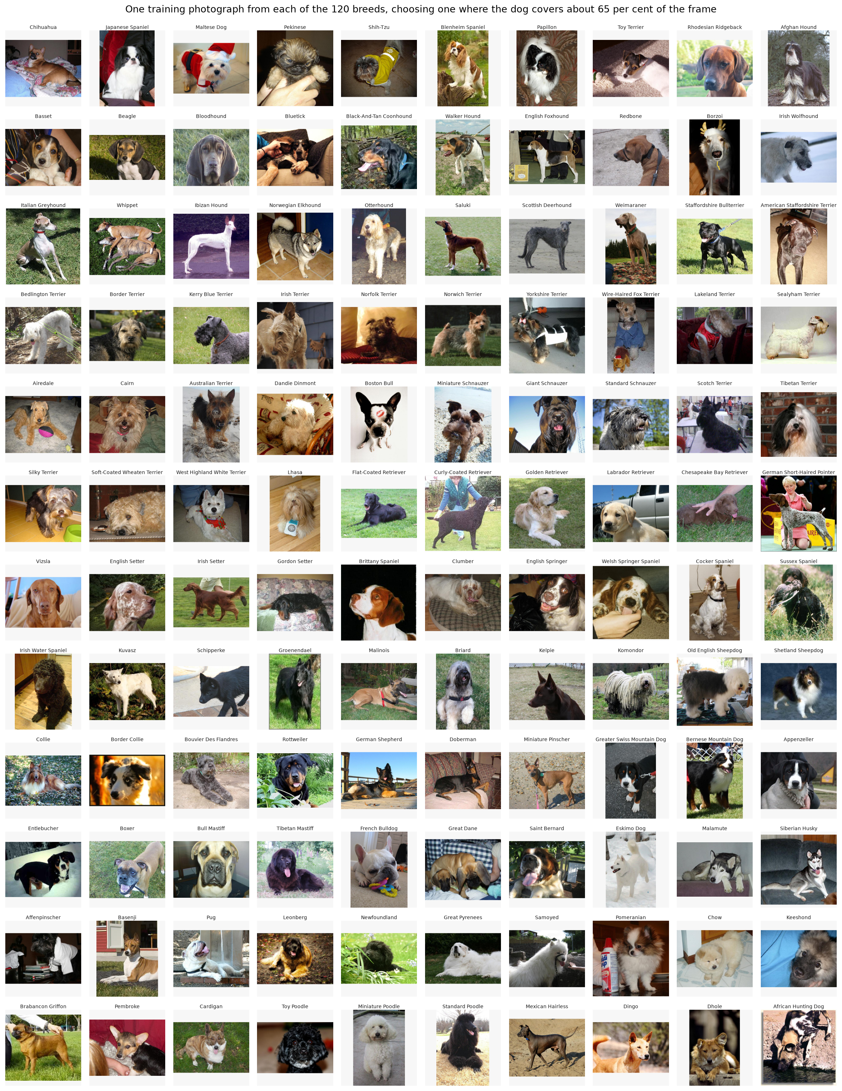
Figure 1: Representative photographs from twelve Stanford Dogs classes

3.3 Composition, Class Balance, and Image Properties
Table 1: Stanford Dogs Dataset Composition and Photographic Characteristics
Measure | Value
Photographs | 20,580
Breeds (classes) | 120
Photographs per breed | 148 (redbone) to 252 (Maltese dog)
Mean, median per breed | 171.5, 159.5
Largest to smallest class ratio | 1.70 to 1
Median image size | 500 × 375 pixels
Smaller than 224 pixels on one side | 1,577 (7.66%)
Median share of frame occupied by the dog | 55.3%
Photographs with more than one dog | 6.60%

As summarised in Table 1, the number of photographs per breed ranges from 148 (redbone) to 252 (Maltese dog), with a mean of 171.5 and a median of 159.5. The distribution is right-skewed (Figure 2): most breeds contain close to 150 photographs, while a minority contain considerably more. The ratio between the largest and smallest class is 1.70 to 1, which was judged to be a mild imbalance. Macro-averaged F1 is nevertheless reported alongside accuracy, since it gives each breed equal weight and so cannot be inflated by strong performance on the larger classes.
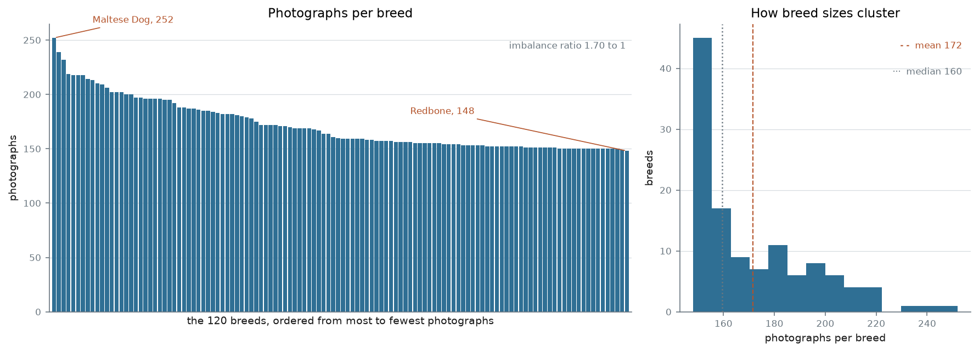
Figure 2: Photographs per breed, sorted, and the distribution of breed sizes
Image dimensions vary widely, from 97 to 3,264 pixels in width and from 100 to 2,562 pixels in height, with median dimensions of 500 by 375 pixels. The distribution of dimensions shows a sharp boundary at 500 pixels on both axes, which suggests that most photographs were downscaled to a maximum of 500 pixels on their longest side before publication, reducing the fine detail available for distinguishing breeds. In addition, 7.66 per cent of photographs (1,577) fall below 224 pixels on at least one side, the input size used by all models, and are enlarged at load time with some loss of sharpness. Most photographs are landscape (68.72 per cent), with 25.95 per cent portrait and 5.33 per cent approximately square, so resizing to a square input alters the proportions of most images (Section 5.1).
The bounding-box annotations show that the dog occupies a median of 55.3 per cent of the frame, and that in 14.52 per cent of photographs it occupies less than a quarter. Furthermore, 6.60 per cent of photographs contain more than one dog, up to six in a single image, while carrying only one breed label. Such photographs are inherently ambiguous, since a model may correctly identify a dog in the image without matching the labelled one, an effect examined in Section 7.2.

3.4 Data Cleaning and Integrity Verification
Cleaning began with an integrity check of every file in the dataset. All 20,580 photographs and their 20,580 annotation files were present, and every photograph decoded without error. The only formatting problem found was a single photograph in RGBA format, which includes a transparency channel, and it is converted to RGB at load time so that all inputs share the same three colour channels.
Duplicate photographs were searched for next, because the specification requires that near-identical images are not divided between training and test data. Byte-for-byte copies were found by comparing a unique digital fingerprint (a SHA-256 hash) of every file, yielding 89 groups of identical files, of which 37 fell into different partitions. Because resized or recompressed copies of the same photograph have different bytes, two perceptual fingerprints were also computed for every image, a difference hash (dHash) and a perceptual hash (pHash), each of which changes only slightly when an image is altered slightly. Choosing the matching threshold required judgement, so seven thresholds were evaluated: agreement between the two methods fell from 93.9 per cent at the strictest setting to 13.4 per cent at a distance of 10, and visual inspection of sampled pairs showed that matches beyond a distance of 6 were frequently different photographs. A pair was therefore treated as a duplicate only if both methods agreed, with a difference-hash distance of 5 or less and a perceptual-hash distance of 10 or less, which identified 173 confirmed pairs, 74 of them split across partitions.
In the main 120-class condition, no photographs were removed: the duplicates were instead flagged and their effect on test performance measured (Section 3.6), so that all models could continue to use the shared split.Removal was applied only in the simplified condition, in which 170 duplicate and leaked photographs were excluded (Section 3.7).
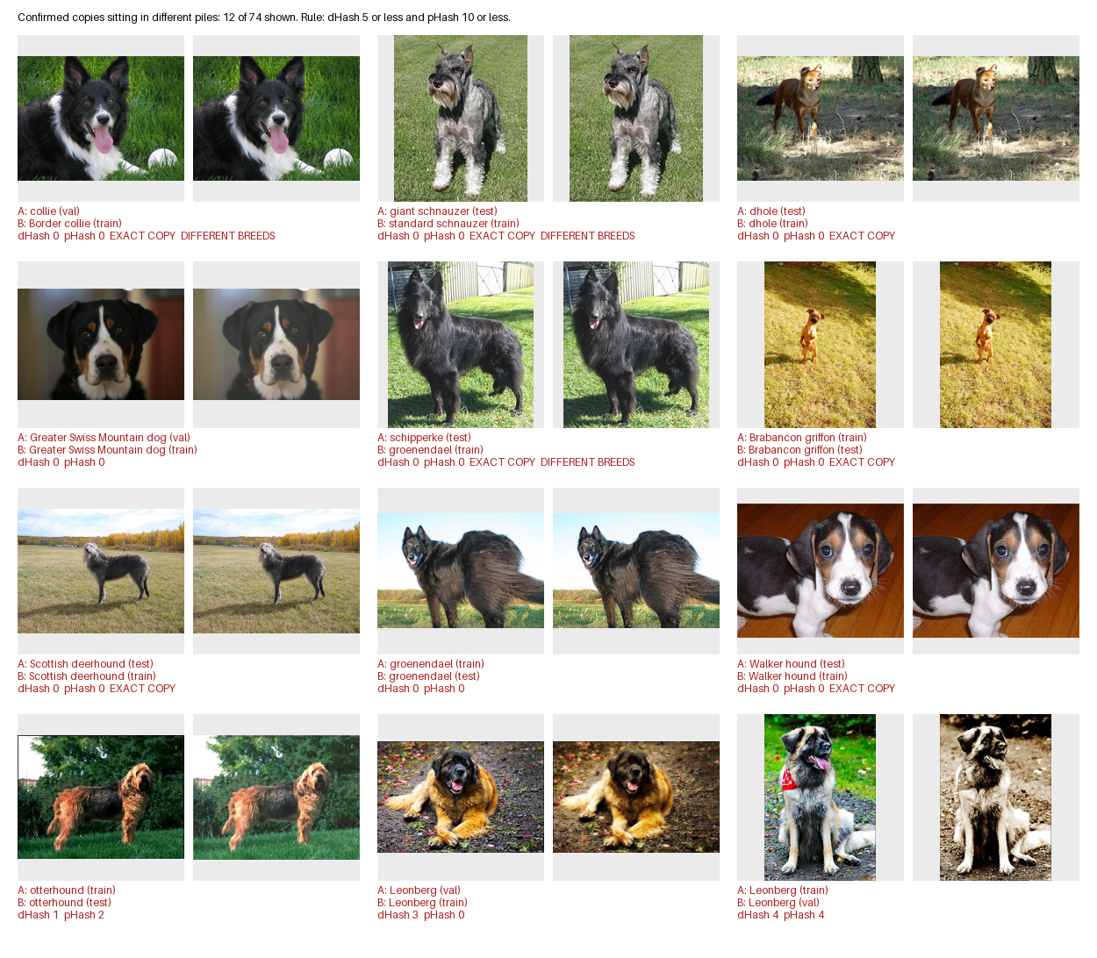
Figure 2b: Confirmed duplicate and leaked photo pairs detected during data cleaning across partition boundaries and conflicting breed synsets.
Figure 2b illustrates representative duplicate pairs isolated by the automated perceptual hashing audit. Each pair visually demonstrates cross-split contamination and conflicting annotations (such as identical photos labeled under both Walker Hound and English Foxhound synsets). During the cleaning phase, an interactive inspection workflow enabled systematic verification, categorizing pairs into confirmed duplicates for excision in the simplified condition (Section 3.7) while preserving the shared baseline manifest for benchmark reproducibility.

3.5 Ground-Truth Label Audit and Noise Evaluation
Labels in Stanford Dogs are those assigned when the photographs were collected for ImageNet, and no relabeling is reported by the dataset’s authors (Khosla et al., 2011). ImageNet’s labels were verified by crowd workers through Amazon Mechanical Turk rather than by breed experts (Deng et al., 2009), so their reliability for closely related breeds could not be assumed. Among the duplicate pairs identified in Section 3.4, 50 carry two different breed labels, and these pairs involve 40 of the 120 breeds. In most such cases, one of the labels must be wrong, although a photograph containing more than one dog could legitimately appear under two breeds.

3.6 Train/Validation/Test Split and Data Leakage Prevention
The data was split 70/15/15 into training, validation and test sets, stratified by breed so that each breed appears in the same proportion in every set, using random seed 42. The sets are slightly uneven because per-breed counts were rounded down, with the remainder added to the test set. The split was checked before use: it can be regenerated exactly from the seed, no photograph appears in more than one set, every label matches its breed folder, and all 120 breeds appear in every set.
The split was made by random selection and did not account for duplicates, so 34 test photographs (1.06 per cent) have a near-duplicate in the training set. Instead of regenerating the split, the test set was scored twice, with and without these 34 photographs, so that the effect of leakage could be measured (Section 6.5). This measures leakage rather than preventing it, which is listed as a limitation in Section 7.4.

3.7 Simplified Dataset Condition (Taxonomic Breed Merging)
The simplified condition merges four groups of near-identical breeds and removes 170 duplicate and leaked photographs, leaving 114 classes (Table 2). Its purpose is to show how much accuracy is lost to breeds that the dataset labels inconsistently. Results on 114 classes are not directly comparable with those on 120, because merging removes the hardest decisions, so the two are always reported separately.
Table 2: Dataset Experimental Conditions (Original 120-Class vs Simplified 114-Class)
Condition | Classes | Training | Validation | Test
Original (120 class) | 120 | 14,355 | 3,025 | 3,200
Simplified (114 class) | 114 | 14,257 | 2,989 | 3,164
Difference | 4 groups merged | 98 removed | 36 removed | 36 removed

3.8 Ethical, Privacy, and Regulatory Considerations
Many photographs include people who could be identified, and neither source records their consent. This project collected no personal data, and the models only predict dog breeds. The trained models are used only in a private demonstration app and are not publicly deployed or shared.

4. Methodology, Selected Models, and Transfer Learning Approach

4.1 Model Family Selection
Table 3: Summary of Evaluated Model Families and Architectural Roles
Model | Family | Pretrained weights | Parameters | Trainable in phase 2 | Role
Custom CNN | VGG-style CNN | None | 4,581,784 | All (from scratch) | Baseline, no pretraining
EfficientNetV2-S | EfficientNet | ImageNet-1K | 20,331,208 | 74.0% | Efficient CNN
Swin-T | Swin Transformer | ImageNet-1K V1 | 27,611,634 | About 56% | Transformer
MobileNetV3-Large | MobileNet | ImageNet-1K V1 | 4,355,752 | 72.0% | Size-matched control

Three model families were compared (Table 3): a custom convolutional neural network (CNN) trained from scratch, EfficientNetV2-S and Swin-T. They were chosen to contrast learning from scratch with transfer learning, and convolution with attention. MobileNetV3-Large (Howard et al., 2019) is added as a control: it is pretrained but about the same size as the custom CNN, so comparing the two separates the effect of pretraining from the effect of size.

4.2 Baseline Model: Custom Convolutional Neural Network
The custom CNN follows a simple VGG-style design (Simonyan & Zisserman, 2015): five blocks of 3×3 convolution, batch normalisation, ReLU and max pooling, with the number of channels doubling from 32 to 512 as the image shrinks from 224 to 7 pixels. A second convolution in the last two blocks brings the network to 4,581,784 parameters, and global average pooling, dropout and a single output layer complete it. Global average pooling, which averages each feature map into one value, was used instead of a large fully connected layer, saving about 524,000 parameters.

4.3 Transfer Learning CNN: EfficientNetV2-S
EfficientNetV2-S is the smallest model in the EfficientNetV2 family (Tan & Le, 2021), a convolutional design built for both accuracy and training speed. Its main ideas are scaling the network’s depth, width and resolution together, and using simpler, faster “fused” blocks in the early layers. With 20.3 million parameters, it was chosen as a strong but practical convolutional network that can run on ordinary hardware.

4.4 Transfer Learning Vision Transformer: Swin-T
Swin-T (Liu et al., 2021) is a vision transformer, a model that uses self-attention to compare parts of an image with each other directly, rather than scanning it with small filters as a CNN does. A standard Vision Transformer (Dosovitskiy et al., 2021) becomes expensive on larger images and needs very large training sets, which makes it a poor fit for about 20,000 photographs. Swin computes attention within small, shifting windows instead of across the whole image, and merges patches as it goes deeper, much as a CNN shrinks its feature maps. Swin-T is the smallest standard version, with 27.6 million parameters.

4.5 Two-Phase Transfer Learning Strategy
Transfer learning starts from a network already trained on ImageNet and replaces only its final layer with one for the 120 breeds. Training runs in two phases, 2 epochs with the pretrained layers frozen, followed by 3 epochs with the upper layers unfrozen at a lower learning rate. Freezing first stops the large, random updates from the new layer damaging the pretrained features, and the low learning rate afterwards lets those features adapt to dog breeds without being overwritten.
The unfrozen share was matched by parameters, not by layers, at about 72 to 74 per cent for the two CNNs. Swin-T’s structure does not divide as finely, so unfreezing its final stage leaves about 56 per cent trainable, and this difference is reported rather than hidden. All models use the original ImageNet-1K weights, chosen explicitly so that no model starts from a better-trained version than the others.

5. Experimental Setup and Hyperparameters

5.1 Preprocessing and Augmentation Pipeline
All photographs are resized directly to 224×224 pixels and normalised with the ImageNet mean and standard deviation, which the pretrained models expect. Resizing without cropping distorts non-square photographs, but it keeps the whole dog in frame, whereas a centre crop could cut part of it off. Training images are augmented with horizontal flips, rotations of up to 15 degrees and mild colour jitter, while validation and test images are left unchanged. These changes reflect real photographs: a dog facing left is the same breed facing right, photographs are often slightly tilted, and lighting varies, whereas strong colour changes were avoided because coat colour helps identify breeds.

5.2 Hyperparameters and Training Configuration
Table 4: Two-Phase Training Hyperparameters and Optimization Configurations
Setting | Pretrained models | Custom CNN
Optimiser | AdamW, weight decay 0.01 | AdamW, weight decay 1e-4
Learning rate | 3e-4 (phase 1), 1e-5 (phase 2) | 1e-3, cosine decay
Epochs | 2 + 3 | Up to 60, early stopping (patience 5)
Loss | Cross-entropy, label smoothing 0.1 | Cross-entropy
Batch size | 32 | 64
Mixed precision, seed | Yes, 42 | Yes, 42

Table 4 lists the training settings, which are identical for the three pretrained models and differ for the custom CNN only where training from scratch requires it. Training from scratch needs far longer, so the custom CNN ran for up to 60 epochs with early stopping and a higher learning rate.

5.3 Fairness of the Architectural Comparison
To keep the comparison fair, all models share the same split, input size, augmentation, normalisation and evaluation metrics. EfficientNetV2-S and MobileNetV3-Large share identical training and evaluation code, differing only in the model definition. The custom CNN’s longer schedule gives it more opportunity to learn, not less, so the differences do not favour the pretrained models.

5.4 Software, Hardware, and Reproducibility Protocol
Table 5: Computational Hardware Specifications and Training Run Durations
Model | GPU | Training time
Custom CNN | Tesla T4 (Kaggle), 14.6 GB | 64.7 min (59 epochs)
EfficientNetV2-S | RTX 4050 Laptop, 8 GB | 14.7 min
Swin-T | RTX 4060 Laptop, 8 GB | 9.1 min
MobileNetV3-Large | RTX 4050 Laptop, 8 GB | 13.87 min

All models were implemented in PyTorch 2.11.0 (Paszke et al., 2019) with torchvision 0.26.0 and CUDA 12.8, on Windows 11 and Kaggle’s Linux environment. As different GPUs were used, the times indicate scale only, and the clearer contrast is 5 epochs for the pretrained models against 59 for the custom CNN. Seeding fixes the data order and starting weights, but not every GPU operation; repeated runs differed by up to 1.2 points of macro F1, which is taken as the noise level for all comparisons. All development decisions were made on the validation set, and the test set was scored once per final model. Every run saves its settings, library versions and GPU to a configuration file, and full reproduction steps are given in the README.

5.5 Iterative Custom CNN Architecture Development
Table 6: Iterative Custom CNN Architecture Development Runs on Validation Split
Run | Change | Val macro F1 | Train−val gap
1 | Initial design | 0.4969 | 15.8
2A | Stronger regularisation | 0.4911 | 8.9
2B | Extra convolution in blocks 4 and 5 | 0.5649 | 33.0
3A | 2B + stronger regularisation | 0.5602 | 27.2
3B | 2B over 120 epochs | 0.5270 | 23.9

The custom CNN’s final configuration was chosen from five runs, each changing one factor and judged on validation data only (Table 6). The first run appeared to overfit, but stronger regularisation (run 2A) narrowed the gap between training and validation accuracy without improving results, while adding capacity (run 2B) raised macro F1 by 6.8 points despite doubling that gap. This showed that the size of the overfitting gap was a poor guide to what would improve the model. Run 2B was selected, as later runs either matched it within noise (3A) or performed worse (3B).

6. Results, Figures, and Model Comparison

6.1 Overall Benchmark Performance on Held-Out Test Set
Table 7: Overall Model Performance Comparison on the Held-Out Test Set
Model | Params (M) | Top-1 | Top-5 | Macro F1 | Clean test top-1 (3,166) | Top-1, 114 classes
Custom CNN | 4.58 | 53.84% | 84.78% | 0.532 | 53.63% | Not run
MobileNetV3-Large | 4.36 | 67.53% | 91.75% | 0.671 | Not computed | 68.74%
EfficientNetV2-S | 20.33 | 83.12% | 97.75% | 0.825 | 83.25% | 84.54%
Swin-T | 27.61 | 88.03% | 99.31% | 0.875 | 88.21% | 89.92%

On the test set, Swin-T achieved the highest accuracy at 88.03 per cent, followed by EfficientNetV2-S (83.12), MobileNetV3-Large (67.53) and the custom CNN (53.84) (Table 7). For every model, macro F1 is within about one point of accuracy, so performance is spread evenly across breeds rather than concentrated in the larger classes. At almost identical size, the pretrained MobileNetV3-Large outperformed the custom CNN by 13.69 points while training for 5 epochs rather than 59. Top-5 accuracy is high for every model, from 84.78 per cent for the custom CNN to 99.31 per cent for Swin-T, so the correct breed is usually among each model’s five best guesses.

6.2 Comparative Learning Dynamics and Loss Curves
The learning trajectories for all evaluated models are illustrated in Figures 3 and 4. The experimental curves reveal fundamentally distinct optimization dynamics between learning from scratch and transfer learning:
1. Transfer Learning Dynamics (Phase 1 vs. Phase 2): As shown in Figure 4, all pretrained models (Swin-T, EfficientNetV2-S, and MobileNetV3-Large) achieve rapid convergence. During Phase 1 (Epochs 1-2, frozen backbone), validation accuracy surges past 60% within the initial two epochs as the newly initialized classifier head rapidly aligns with the frozen ImageNet representations. Upon entering Phase 2 (Epochs 3-5, unfreezing upper stages with a reduced learning rate of 1e-5), validation accuracy climbs a further 5 to 8 percentage points without catastrophic forgetting. By Epoch 5, validation curves level off smoothly, indicating optimal convergence.
2. From-Scratch Convergence Profile: In sharp contrast, Figure 3 demonstrates that the custom CNN requires gradual, extensive training across 59 epochs. Without pre-existing feature detectors, training loss decreases slowly, while validation macro F1 improves steadily from near-zero to plateauing around 50% by Epoch 54 before triggering early stopping. The noticeable gap between training and validation loss reflects natural capacity limits when learning complex representations from only ~120 images per class.
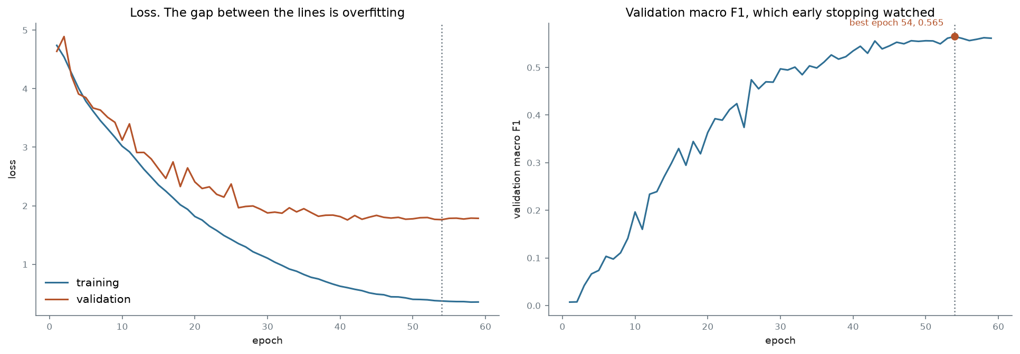
Figure 3: Custom CNN training and validation loss, and validation macro F1
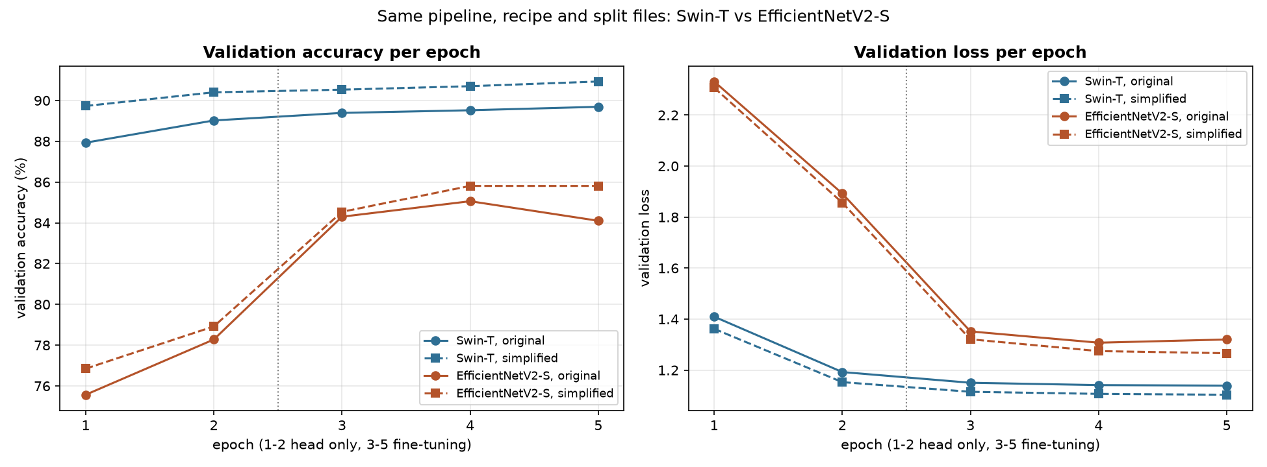
Figure 4: Validation accuracy per epoch for the pretrained models

6.3 Fine-Grained Per-Class Performance and Weakest Classes
Table 8 highlights the weakest performing classes for each model family, with complete per-class precision, recall, and F1-scores documented in Appendix A. In fine-grained multiclass evaluation, the F1-score represents the harmonic mean of precision (avoiding false breed assignments) and recall (capturing true breed instances), defined as F1 = 2?(Precision?Recall)/(Precision + Recall). An F1-score below 0.30 indicates severe systematic misclassification: the model either routinely misses dogs of that breed (low recall) or frequently confuses other breeds for it (low precision).
Crucially, the weakest classes are shared across both convolutional and transformer architectures. Breeds such as the Eskimo Dog, Miniature Poodle, and Collie consistently exhibit the lowest F1-scores across all models. For example, the Eskimo Dog achieves an F1 of only 0.208 on the custom CNN and 0.276 on Swin-T, directly reflecting the contradictory ground-truth labeling in the dataset where identical photos are dual-labeled as Siberian Huskies and Eskimo Dogs.

Table 8: Five Weakest Performing Breeds (Lowest Macro F1) Across Evaluated Models
Custom CNN | F1 | MobileNetV3-Large | F1 | Swin-T | F1
Miniature poodle | 0.195 | Rhodesian ridgeback | 0.286 | Eskimo dog | 0.276
Am. Staffordshire terrier | 0.208 | Miniature poodle | 0.294 | Collie | 0.303
Eskimo dog | 0.208 | Collie | 0.316 | Lhasa | 0.480
Standard schnauzer | 0.227 | Lhasa | 0.392
Miniature schnauzer | 0.233 | Redbone | 0.394

6.4 Confusion Matrix Analysis
Figure 5 shows the confusion matrix for Swin-T, with a zoomed view of the breeds most often confused. For the custom CNN, the Eskimo dog was predicted as a Siberian husky 10 times, more often than it was classified correctly.
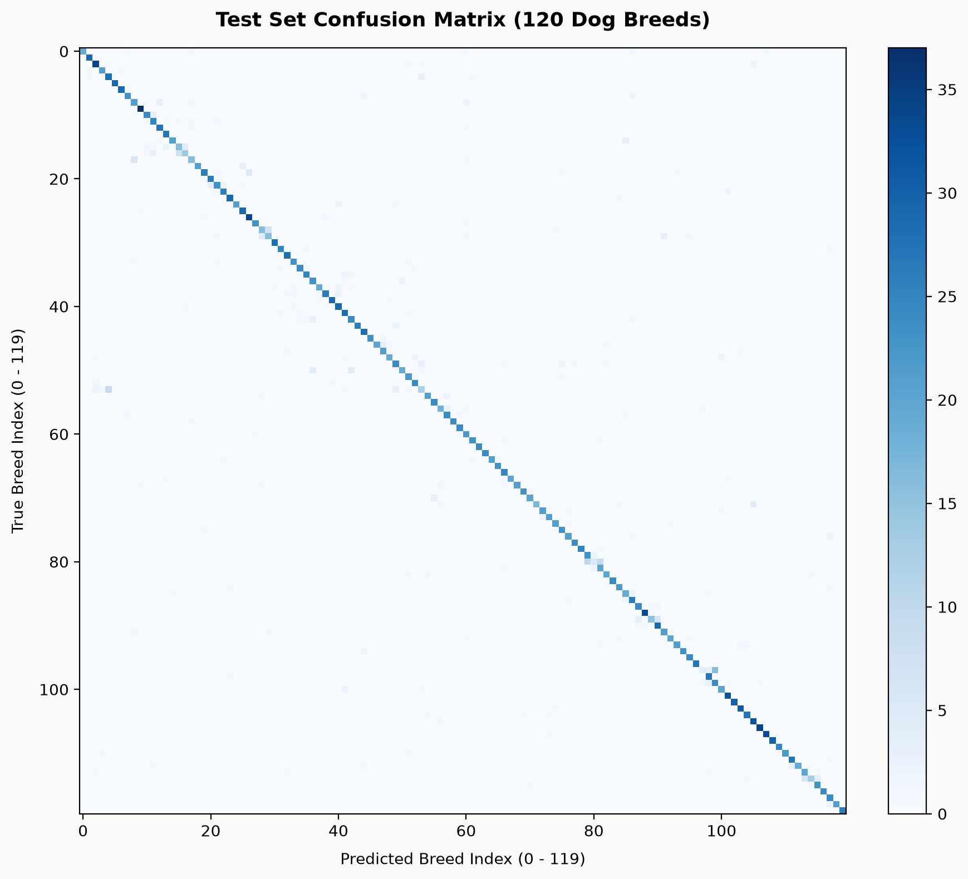
Figure 5
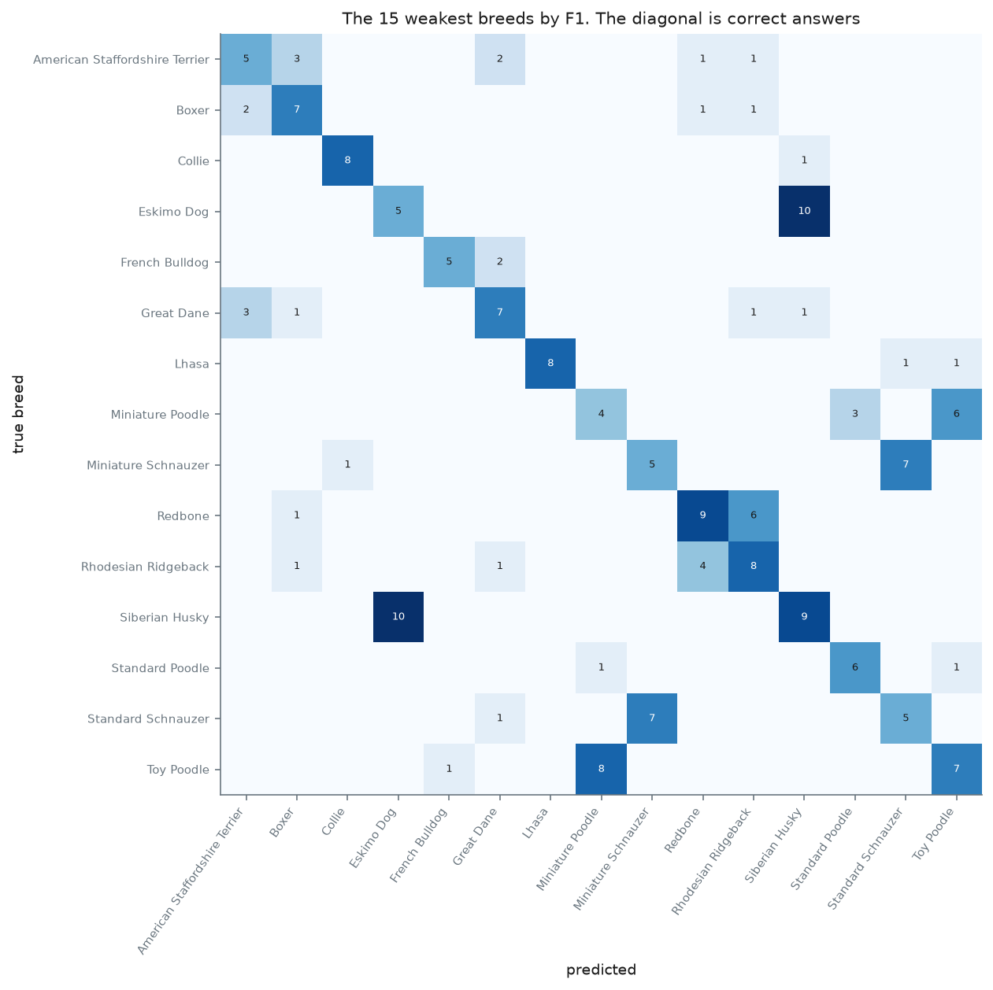

6.5 Qualitative Prediction Analysis and Leakage Impact
Figure 6 shows examples of correct and incorrect predictions from Swin-T, with the predicted breed and confidence for each. The errors fall into three types, matching the dataset issues in Section 3: look-alike breeds, small dogs and photographs with more than one dog. Removing the 34 test photographs with a duplicate in training changed top-1 accuracy by less than a quarter of a point for every model, in both directions (Table 7). Merging the look-alike breeds raised accuracy for every pretrained model by 1.2 to 1.9 points, although these figures are not directly comparable with the 120-class results (Section 3.7). Only Swin-T’s gain (1.89 points) clearly exceeds the noise level, which suggests that the look-alike breeds account for a small share of the remaining errors.
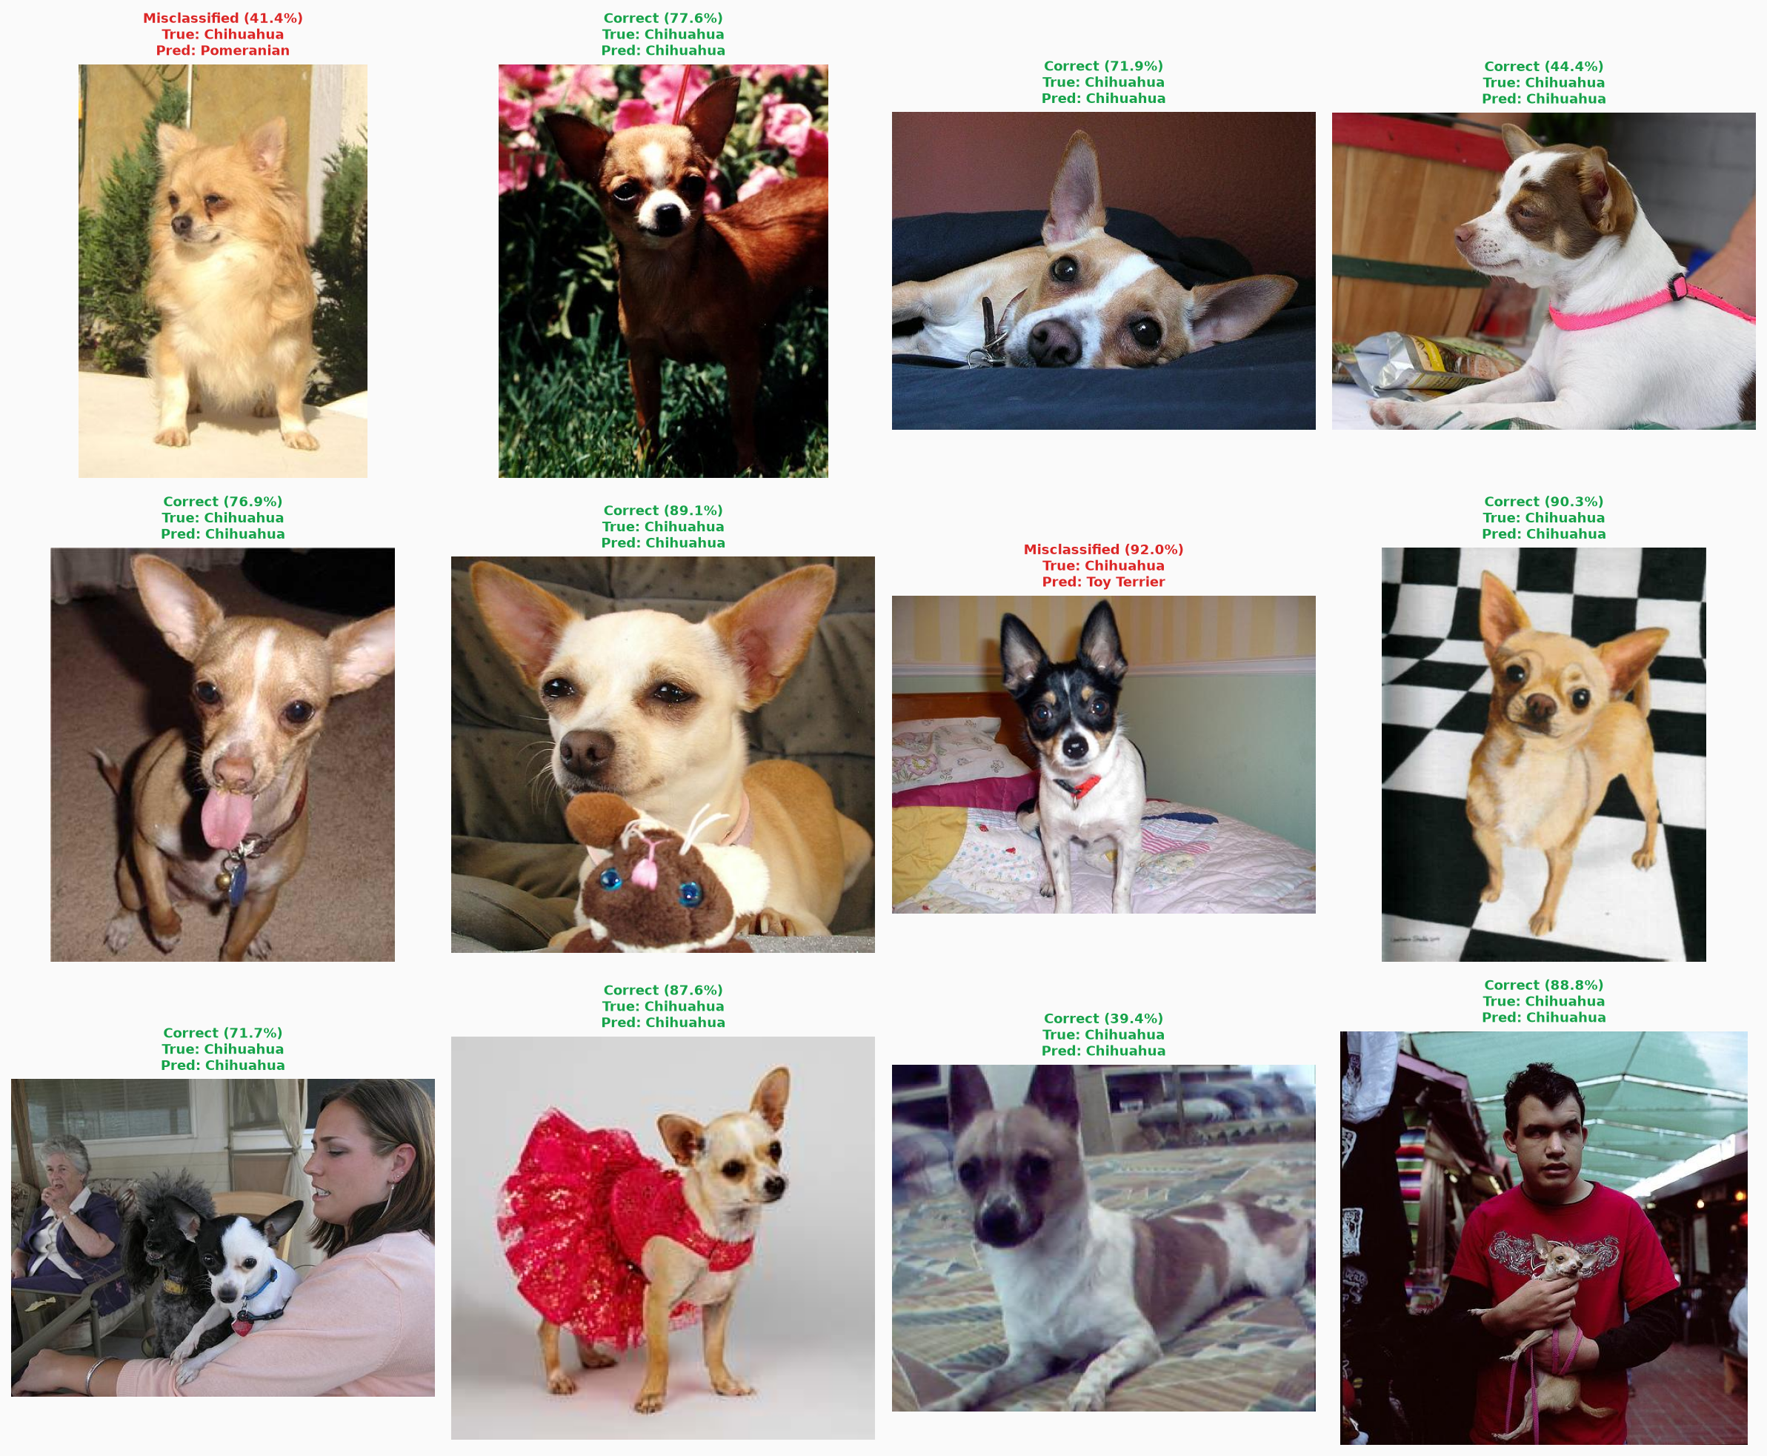
Figure 6: Swin-T example predictions

7. Discussion, Limitations, and Error Analysis

7.1 Architectural and Pretraining Performance Drivers
Pretraining made the largest single difference: all three pretrained models outperformed the custom CNN, including the one of the same size. A pretrained network starts with general visual features already learned, so the small amount of training data can be spent on breed differences alone. Swin-T outperformed EfficientNetV2-S by 4.91 points, possibly because attention can relate distant parts of the dog, such as the ears and tail, but it is also the larger model, so the two effects cannot be separated here.

7.2 Detailed Error and Confusion Pattern Analysis
The gap between the custom CNN’s top-1 (53.84 per cent) and top-5 accuracy (84.78 per cent) shows that it usually narrows a photograph down to the right few breeds but then picks the wrong one. Only 7.7 per cent of its errors were made with 90 per cent confidence or more, so the model is usually uncertain when it is wrong. Its failures are therefore mostly about telling similar breeds apart, not about recognising dogs at all.
Many of the most frequent errors fall on breed pairs with contradictory labels, such as the Eskimo dog and Siberian husky. Errors that run both ways suggest that the boundary between the breeds is unclear in the data itself, rather than that the model is biased towards one breed. Swin-T’s weakest classes include the same Eskimo dog and husky pair, so two very different architectures struggle on the same breeds, which points to the data rather than the models.
Some breeds can barely be separated from a photograph: the poodle and schnauzer varieties differ mainly in height, and a 224×224 image gives no sense of scale. These classes are among the weakest for the custom CNN, and they are also the groups merged in the simplified condition. Photographs with more than one dog (6.60 per cent) produce errors that standard metrics count as wrong even when the predicted breed is present, as in a schipperke photograph classified as a collie (Figure 6).

7.3 Theoretical and Scientific Implications of the Comparison
One way to read the 34.19-point gap is in two steps: pretraining at the same size added 13.69 points (custom CNN to MobileNetV3-Large), and moving to larger, newer architectures added a further 20.50 (MobileNetV3-Large to Swin-T). This should not be read as transfer learning being worth a fixed share of the gap, because the benefit of pretraining is likely to grow with model size, and a transformer trained from scratch on this little data would probably perform far worse than the custom CNN. MobileNetV3-Large also differs from the custom CNN in architecture, so the 13.69 points reflect pretraining and a more refined design together. Even so, MobileNetV3-Large reused settings designed for EfficientNetV2-S and trained for only 5 epochs, so its result is unlikely to overstate the benefit of pretraining.
Since Stanford Dogs comes from ImageNet, the pretrained models may have encountered some test photographs before (Section 3.1). The size of this effect was not measured, so the pretrained scores should be treated as possibly optimistic. Transfer learning remains standard and useful practice, and the point is only that on this dataset its scores need to be read with care.

7.4 Threats to Validity and Experimental Limitations
- Each model was trained once, so differences smaller than about 1.2 points may be noise.
- The pretrained models trained for only 5 epochs and may still have been improving.
- Possible overlap between the ImageNet pretraining data, and the test set was not measured.
- The split did not keep duplicates together, so leakage was measured rather than prevented.
- Contradictory labels and photographs with several dogs limit the accuracy any model can reach.
- Photographs were downscaled before publication and distorted by square resizing.
- The label audit covered only 100 photographs and was carried out by non-experts.
- Models ran on different GPUs, so training times are not directly comparable.

8. Conclusion and Model Recommendation

8.1 Key Scientific Findings and Final Recommendation
This project compared a custom CNN, EfficientNetV2-S and Swin-T, with MobileNetV3-Large as a size-matched control, on the 120-class Stanford Dogs task. The pretrained models clearly outperformed the custom CNN, with Swin-T reaching 88.03 per cent top-1 accuracy against 53.84 per cent, and pretraining at the same model size added 13.69 points. The dataset audit found that leakage made almost no difference, but that inconsistent labels limit how accurate any model can be.
Swin-T is recommended, as it achieved the highest accuracy and macro F1 of the models tested. EfficientNetV2-S is a reasonable alternative where a convolutional model is preferred, at a cost of about 5 points. Future work should evaluate the models on a separately collected test set to remove any overlap with ImageNet. Training Swin-T from scratch would show directly how much pretraining matters for a transformer.

9. References
DENG, J., DONG, W., SOCHER, R., LI, L.-J., LI, K. & FEI-FEI, L. 2009. ImageNet: a large-scale hierarchical image database. Paper presented at the IEEE Conference on Computer Vision and Pattern Recognition, Miami, FL.
DOSOVITSKIY, A., BEYER, L., KOLESNIKOV, A., WEISSENBORN, D., ZHAI, X., UNTERTHINER, T., DEHGHANI, M., MINDERER, M., HEIGOLD, G., GELLY, S., USZKOREIT, J. & HOULSBY, N. 2021. An image is worth 16x16 words: transformers for image recognition at scale. Paper presented at the International Conference on Learning Representations.
HE, K., ZHANG, X., REN, S. & SUN, J. 2015. Delving deep into rectifiers: surpassing human-level performance on ImageNet classification. Paper presented at the IEEE International Conference on Computer Vision, Santiago.
HOWARD, A., SANDLER, M., CHU, G., CHEN, L.-C., CHEN, B., TAN, M., WANG, W., ZHU, Y., PANG, R., VASUDEVAN, V., LE, Q.V. & ADAM, H. 2019. Searching for MobileNetV3. Paper presented at the IEEE International Conference on Computer Vision, Seoul.
IOFFE, S. & SZEGEDY, C. 2015. Batch normalization: accelerating deep network training by reducing internal covariate shift. Paper presented at the International Conference on Machine Learning, Lille.
KHOSLA, A., JAYADEVAPRAKASH, N., YAO, B. & FEI-FEI, L. 2011. Novel dataset for fine-grained image categorization. Paper presented at the First Workshop on Fine-Grained Visual Categorization, IEEE Conference on Computer Vision and Pattern Recognition, Colorado Springs, CO.
LIU, Z., LIN, Y., CAO, Y., HU, H., WEI, Y., ZHANG, Z., LIN, S. & GUO, B. 2021. Swin Transformer: hierarchical vision transformer using shifted windows. Paper presented at the IEEE International Conference on Computer Vision, Montreal.
LOSHCHILOV, I. & HUTTER, F. 2019. Decoupled weight decay regularization. Paper presented at the International Conference on Learning Representations, New Orleans, LA.
PASZKE, A., GROSS, S., MASSA, F., LERER, A., BRADBURY, J., CHANAN, G., KILLEEN, T., LIN, Z., GIMELSHEIN, N., ANTIGA, L., DESMAISON, A., KOPF, A., YANG, E., DEVITO, Z., RAISON, M., TEJANI, A., CHILAMKURTHY, S., STEINER, B., FANG, L., BAI, J. & CHINTALA, S. 2019. PyTorch: an imperative style, high-performance deep learning library. Paper presented at Advances in Neural Information Processing Systems, Vancouver.
PYTORCH. 2026. torchvision models documentation. [Online.] Available: https://pytorch.org/vision/stable/models.html [Accessed: 18 October 2026.]
SIMONYAN, K. & ZISSERMAN, A. 2015. Very deep convolutional networks for large-scale image recognition. Paper presented at the International Conference on Learning Representations, San Diego, CA.
TAN, M. & LE, Q.V. 2021. EfficientNetV2: smaller models and faster training. Paper presented at the International Conference on Machine Learning.

Appendix A: Complete Per-Class Performance Metrics (120 Breeds)
Precision, recall and F1 for all 120 breeds, for every model, are provided as CSV files in the project repository rather than reproduced here, since the full tables run to several pages. For the custom CNN see Lindani_Model/results/runs/iter2_deeper/eval_test/per_class_metrics.csv, for MobileNetV3-Large see Lindani_Model/mobilenet/results/runs/mobilenet_unclean/eval_test/per_class_metrics.csv, and for the other two models the equivalent files in JP_Model and Sulaiman_Model. Appendices do not count towards the page limit.

